PRACTICAL 1

Q1. Create and transform vectors and matrices (the transpose vector (matrix) conjugate a. transpose of a vector (matrix)
Sol: INPUT :-
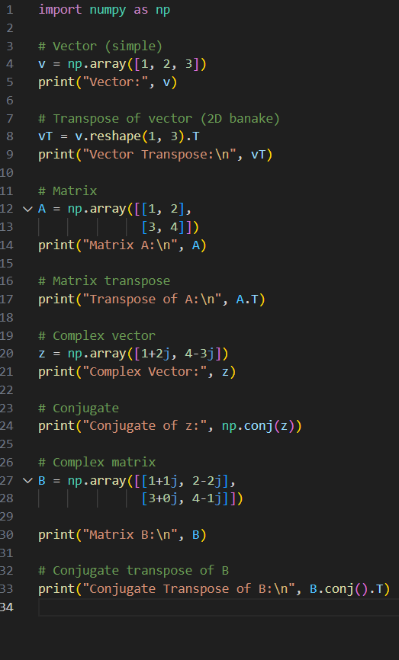
OUTPUT :-
